This is a web-based tool, no software download required, that provides a collaborative platform to design and share teaching resources. Full access requires a subscription, although, FREE TOOLS are accessible here:

<http://www.noodletools.com/tools/freetools.php>



### Additional Resources

SLIS

University of Kentucky

Tech4InfoLit.wordpress.com

## Alexa Clark & Angelia Pulley

# Tech Resources for Information Literacy

LOEX 2014

Animation Tools

* PowToon
* GoAnimate
* Wideo
* Prezi

Screencasting Tools

* Camtasia
* Screenflow
* Jing
* Captivate
* Screenr

Infographic Tools

* Easel.ly
* Infogr.am
* Visual.ly
* Piktochart

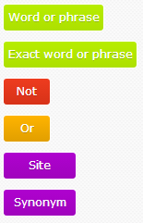

<http://www.boolify.org/>

Boolify helps to searching the web by visualizing the process with a graphical representation using Boolean logic as a puzzle.

The learner can change search results by connecting different pieces of the puzzle.

This provides real-time feedback.



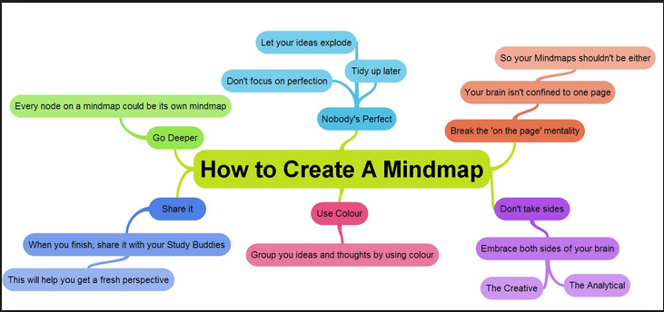

<http://mind42.com/>

Mind42 is a free, fast and simple online mind mapping application.

Mind mapping is about collecting ideas in a graphical way. Ideas get arranged in a tree or star like diagram to visualize connections between different topics.



### Web Resources